**Final Project Proposal**

**Project Title**:  End-to-End DevOps Automation Pipeline on AWS EKS with Terraform, GitHub Actions, and GitOps

Submission Date: 4/12/2025

# 1. Project Description

# This project aims to design and implement a complete, automated DevOps pipeline for deploying a scalable web application on Amazon Elastic Kubernetes Service (EKS). The pipeline embodies modern DevOps practices, including Infrastructure as Code (IaC), Continuous Integration (CI) via GitHub Actions, Continuous Deployment (CD) via GitOps, and integrated security scanning.

# The project will use Terraform to provision the entire AWS foundation (VPC, EKS, S3, CloudWatch, SNS). GitHub Actions will orchestrate the CI pipeline, automating Docker image builds, vulnerability scanning with Trivy, and pushing images to Docker Hub. Crucially, the project implements a GitOps workflow using Argo CD to automatically synchronize and deploy applications to the EKS cluster whenever Kubernetes manifests in Git are updated. The pipeline concludes with automated notifications via Amazon SNS to Gmail.

# 2. Architecture Diagram

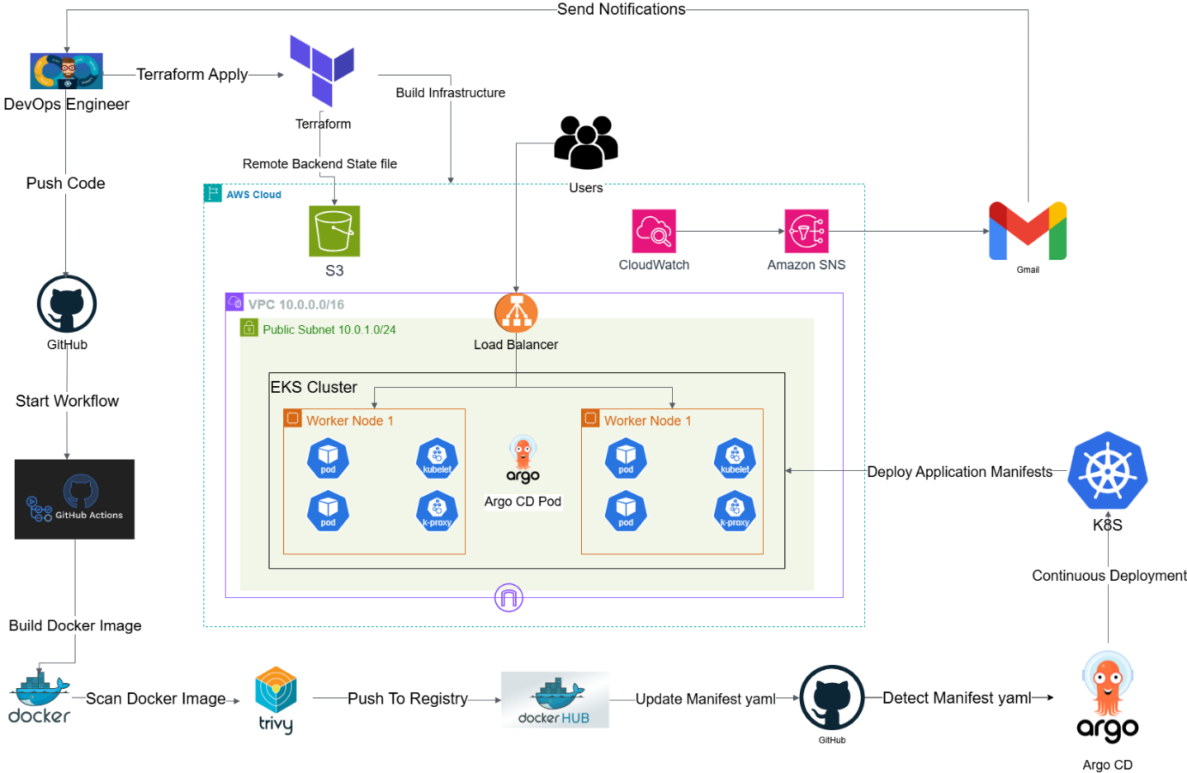

# 2. Group Members & Roles

|  |  |  |
| --- | --- | --- |
| **Member Name** | **Role** | **Responsibilities** |
| Ahmed Mohamed  Sabeh Mohamed | Team Leader / Terraform Core  Infrastructure Engineer | Design & build AWS infrastructure with Terraform (VPC, EKS, S3, CloudWatch, SNS) |
| Nader Ibrahim  Hamouda  Abelkarem | GitHub Actions Engineer | Build and maintain GitHub Actions workflows, integrate Docker Hub, manage CI pipeline |
| Ahmed Ezzat  Hussein Abd  Elsalam | Docker & Image  Management Engineer | Create Dockerfiles, manage container build process, integrate Trivy scanning |
| Mina Ibrahim  Mikhaiel Gerges | Kubernetes (EKS) Engineer | Develop Kubernetes manifests, install and configure Argo CD for GitOps deployments |
| Michael Sameih Wilson Garas | Infrastructure & Automation Engineer | Assist with Terraform modules, optimize AWS resource configuration |
| Mohamed Salah Ismail Mohamed | Monitoring &  Documentation  Engineer | Configure CloudWatch dashboards and SNS notifications, maintain documentation |

**3. Team Leader**

Ahmed Mohamed Sabeh

# 4. Objectives

* Automate the provisioning of a secure AWS environment using Terraform with remote S3 backend state management
* Implement a GitHub Actions-based CI pipeline to build, scan, and push Docker images to Docker Hub
* Integrate Trivy for static analysis of Docker images to identify and block vulnerabilities early
* Adopt a GitOps methodology using Argo CD to automate and manage deployments to EKS
* Implement automated notifications via Amazon SNS to Gmail for pipeline events
* Ensure a scalable and resilient application deployment on EKS using managed node groups
* Configure CloudWatch for monitoring and observability

# 5. Milestones & Deadlines

|  |  |  |
| --- | --- | --- |
| Milestone | Description | Deadline |
| 1. Core Infrastructure (Terraform) | Provision VPC, EKS cluster, S3 backend, CloudWatch, and SNS using Terraform | Nov 1, 2025 |
| 2. Container & Security Pipeline | Create Dockerfile for the application. Integrate Trivy scanning into GitHub Actions | Nov 3, 2025 |
| 3. GitOps Foundation (Argo CD) | Install and configure Argo CD on the EKS cluster. Set up application manifests and sync policies | Nov 10, 2025 |
| 4. GitHub Actions CI Pipeline | Build GitHub Actions workflow to: Build → Scan with Trivy → Push to Docker Hub → Update K8s Manifests in Git | Nov 20, 2025 |
| 5. Monitoring & Notifications | Configure CloudWatch alerts and SNS notifications to Gmail. Integrate with pipeline events | Nov 25, 2025 |
| 6. Validation & Documentation | Perform end-to-end testing. Verify Argo CD auto-deploys changes. Complete project documentation | Dec 4, 2025 |

# 

# 

# 

# 6. Tools & Technologies

|  |  |
| --- | --- |
| Cloud Provider | Amazon Web Services (AWS) |
| Infrastructure as Code (IaC) | Terraform |
| Source Code Management | Git, GitHub |
| CI/CD & Automation | GitHub Actions |
| Containerization | Docker |
| Container Registry | Docker Hub |
| Container Orchestration | Amazon EKS (Kubernetes) |
| GitOps | Argo CD |
| Security Scanning | Trivy |
| Notifications | Amazon SNS |
| Networking | VPC, Load Balancer |
| Remote State Management | Amazon S3 |

# 

# 

# 

# 7. Key Performance Indicators (KPIs)

|  |  |
| --- | --- |
| Category | KPI Description |
| Infrastructure as Code | 100% of AWS infrastructure is provisioned and version-controlled via Terraform. |
| Pipeline Efficiency | CI pipeline (build, scan, push) completes in under 7 minutes. |
| Security | 100% of Docker images are scanned with Trivy; critical vulnerabilities block deployment. |
| Deployment Automation | All deployments to EKS are managed automatically by Argo CD via Git commits (GitOps). |
| Reliability | The system achieves zero-downtime deployments and maintains 99.9% service availability. |
| Monitoring | All critical pipeline events trigger SNS notifications within 2 minutes |

# 8. Conclusion

This project delivers a state-of-the-art, automated DevOps platform on AWS. By leveraging Terraform for IaC, GitHub Actions for CI, and Argo CD for GitOps, it creates a robust, secure, and auditable path from code commit to production. This implementation demonstrates mastery of modern cloud-native tools and establishes a repeatable pattern for efficient and reliable software delivery, fully aligned with the provided architectural vision.